ARM CHALLENGE – this pattern has been designed for learning the intricacies of making and stuffing an arm. This is only one way but it is the one I prefer.
Usually it would have a rounded head, but for those who are learning, it is easier to work with an open top. If you are more confident, you can use the rounded top version.

Arm Pattern
NOTE: This pattern is what is referred to as a “Template” – there are no seams allowed
(just follow instructions).

This symbol indicates the direction of most stretch on fabric – almost all fabric has more stretch in one direction than the other, even cotton!
Line up the weave with this marker.
Supplies:
- Freezer Paper
- Fabric – calico or cotton with
a little bit of “give” – and
dense enough not to show
every lump and bump!
- Thread the same or a lighter
shade
- Acrylic Gel Medium
(see Trimming)
- Turning Tool (see Turning)
- Chenille Stems
- Soft Polyester Stuffing with
no lumps!
Freezer Paper This is paper coated with a thin plastic film on one side – available from patchwork and quilting shops. Look for the plastic laminated brown paper used to cover school books - this is the same, just not white and also much cheaper!

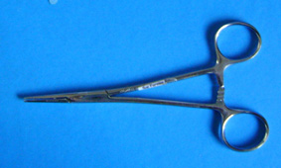 | Forceps (or Haemostats) commonly used in Teddy Bear making.  These are quite small and can get up inside fingers to grip the tip and pull them inside out.  Good strong tweezers or small nosed pliers may also work.
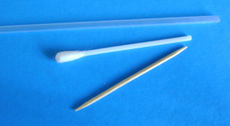 | Turning tools if you don’t have forceps or Turning Rods:  Top: The inside of a ballpoint pen (well-cleaned!) or the tube from inside a spray bottle  Middle: a Cotton Bud with the tip removed  Bottom: A toothpick with a blunted end
PATTERN:
Trace the pattern onto the freezer paper. Fold double and cut to make a pair. Get used to cutting right on the traced line so that it is precise. If you are stitching on a light colour with white freezer paper, use a marker pen to colour the edge of the paper then you can see where you are going!

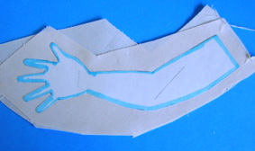 | Iron freezer paper onto the fabric with the plastic side face down – pin in a couple of places to keep the layers together. Mark the opening for stuffing.  DON’T CUT OUT THE ARMS YET – you will do that later.
STITCHING:
Set your machine to a small stitch, but not so small that you get stuck in one spot! (See Tip 1)
Version 1: Start at the top right and stitch right the way round leaving opening on the end.

Tip 1: If you can’t fit 2 stitches between each finger, your stitch size is set too large – change it to a smaller size just while you are doing the fingers (I use 1.5 for the most of the stitching and .5 for the fingers, on a Bernina.) Go slowly and carefully, it is not wasted time.

Version 2: To make it easier when you come to close up the arm later, start stitching at right angles to the seam and then turn to follow the outline and carefully stitch around the arm and fingers following the edge of the paper (not on the paper)... and again at the end, turn out at right angles.
Tip 2: When going round a tight curve or a corner, always leave the needle right down in the fabric, raise the presser foot and turn the fabric. Put the presser foot back down and continue.
Don’t pull on the fabric – you can break a needle and also distort the piece.
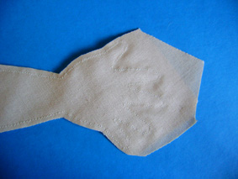 | Put a little blob of Acrylic Texture Medium onto a plastic lid and mix in one drop of water to thin it slightly.  Use a small stiff bristled brush to paint from the seam line out to the edge all round the hand and up the arm on both sides of the fabric. This allows you to cut quite closely without danger of fraying problems.  I use this product for anything that will fray – it doesn’t bleed or stain (just don’t add too much water).
Tip 3: Acrylic Gel Medium can be purchased from shops which stock Artists’ Paints. The make is not important. It is the best “fraycheck” I have ever used – you can thin it slightly with water for use on finer fabrics.
TRIMMING:
Clip seams to 2mm around fingers. See diagram for clipping. This can be done while the fabric is still damp.
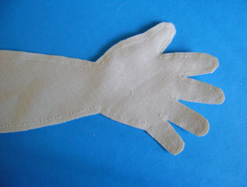
TURNING:
Tiny forceps are the easiest for turning small fingers but not always available. If you do have them, slide them inside the finger and use you fingernail to push the tip down between the jaws – grip – and pull!
Otherwise, cut the tip off a cotton bud. Slide the tube inside the unturned finger then push down against the tube end with the end of a blunt toothpick (slide it between the seam layers at the tip) and gradually work the fabric UP the toothpik, grasping the seam. (You may feel at first as if you need a second pair of hands but just use the table to push against).

Once all fingers are through, turn arm completely to right side, pushing out the fingers carefully with the blunt end of a thin skewer. Flatten the arm. Fingernail-press the seam edges, stretch the hand sideways so that the fingers lie out flat. If you have pleats between the fingers – you haven’t clipped close enough!

WIRING THE HAND:
Cut chenille stems into
3 lengths of 8.5cm and
2 lengths of 15.5cm or longer per arm.

Fold down one end of each stem 1cm and wind a wisp of stuffing tightly around the spot at each raw point. (This will stop the points from poking through at a later stage)
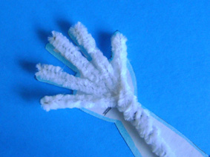 | Lay the folded ends of the stems on the pattern, a long stem each for Thumb and Little Finger and 3 short ones in between.  Place the Thumb Stem on top of the Index Finger Stem (this will give a good thumb shape).  From the line just before the wrist, twist the three short stems tightly around the two long ones, tucking ends in neatly with forceps or pliers.  Twist the two long stems together.
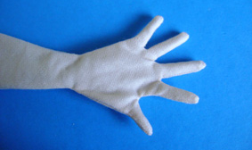 | Push the wires into the hand (make sure the thumb is on the correct side). Press down between the fingers to feed the covering on and make sure the wires go up to the top.
STUFFING THE HAND:
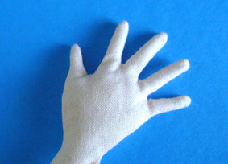 | You may need to put a little stuffing in the base of each finger first.  Then fold a small section of stuffing into a little “pillow” that will fit across the back of the hand.  Grip it firmly in the forceps then position it carefully.
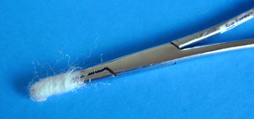 | Prepare 4 or 5 wound wisps of stuffing by gripping the end of a wisp of stuffing and winding it around the forceps or tweezers.  Slide off, ready to use.
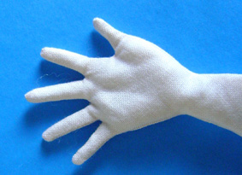 | Use the forceps or tweezers to insert a wound wisp of stuffing:  - across the Base of the Fingers,  - along the Base of the Thumb  (if the Thumb still feels flat, add another  wound wisp there)  - down the Side of the Palm,  - across the Palm at Wrist level,  This will leave you with a dip in the centre of the palm. (I added another piece at the base of the middle finger after this to fill the dent)
Get the hand right before you move on to the wrist and arm!
STUFFING THE WRIST & ARM:
Press the fingers together and pull back the cover to the wrist and start winding the stuffing.
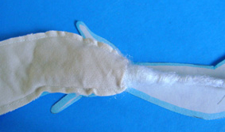 | Tease out wisps of ±15cm long by ±1.75cm.  Starting at Wrist level, wind the stuffing around the wire, along the arm - keeping it as smooth as possible. Pull it in firmly, but not tightly - it should still have some give. Wind to within 2cm of the end of the stems.  Note: The winding on each arm should always be in the same direction.
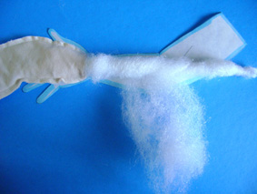 | Lay the arm on the pattern - you will need to pad to at least 2/3 of the width of the pattern. If yours is loosely padded it will the full width.  Pull the cover up to elbow length to check how well it fits.  You may need to wind a little more around the wrist and up onto the forearm.  Keep laying the arm on the pattern piece to check shape – when it matches you are ready to start pulling on the skin.
Tip 4: From time to time grasp the stuffing gently and slide your fingertips around it in the direction of the winding – this will help to firm it up slightly.
Tip 5: Use a needle to push the seams to one side when you have stuffed the pieces – this makes for a much neater finish. You can also use it to rearrange the stuffing if necessary.
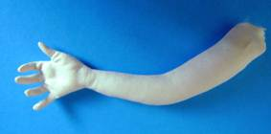 |  | 